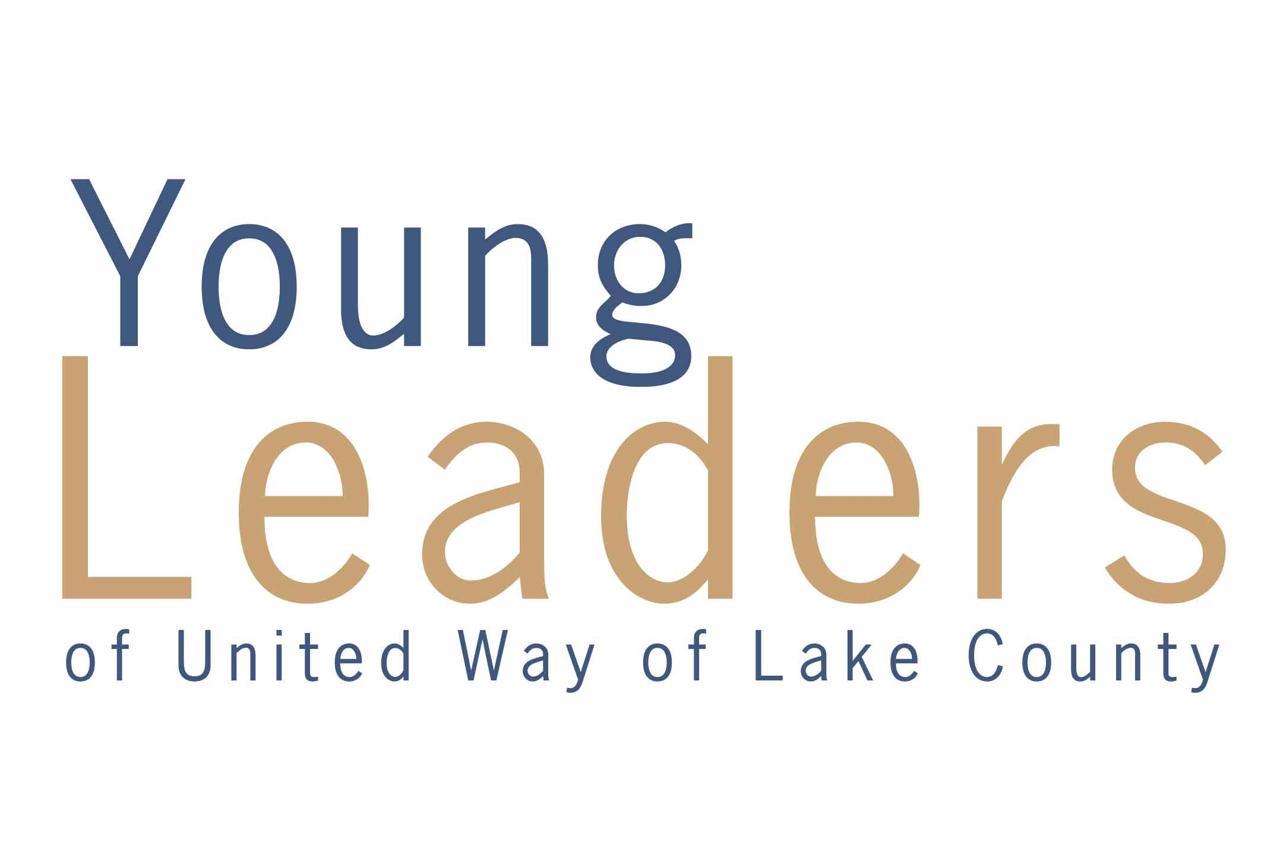
Young Leaders - Associate Board Funding Application
Guidelines for Submission
The mission of Young Leaders of United Way of Lake County is to work to positively impact the lives of Lake County’s youth through improved health and education. To do this, we support 501c3 and non-profit organizations in Lake County with grants that promote this mission.
The total sum of this grant allocation will be up to $10,000 to continue to positively improve the health and education of the youth in Lake County. To submit a grant request, the application must align with the mission of Young Leaders of United Way of Lake County.
The submission guidelines below must be followed. Only typed applications that meet the following guidelines will receive grant consideration.
- Each grant application must include the following:
  - Completed Grant Application Form
  - Bid documentation, if applicable (see Item 2 below)
  - 501c3 approval letter from the IRS (different from the tax exempt form)
  - Any other documents that support the grant request or application.
  - Project budget
  - Program Demographics (found on page 6 of this application)
- Applications must include at least two or more written bids for any equipment and/or materials requested.
  - Every effort must be made to obtain the best prices including any discounts or special prices for a non-profit organization.
  - Specialized equipment where only one source may be available must be accompanied by a statement of explanation supporting the single sourcing.
- Application must be signed by the Executive Director and Board President
- Funding requests for the following will not be accepted:
- salaries
- fundraisers
- gift cards
- gas cards
- bus passes
- Funded requests must be used within six (6) months from the date of receipt.
  - Unused funds must be returned to United Way of Lake County.
  - A follow-up report, including receipts, is due within this same timeframe.
  - A potential site visit can also be scheduled during this timeframe.
- Funding requests must be post marked by June 30, 2017. Agencies not funded will be notified by September 1, 2017. Agencies being funded will be presented with a funding award on September 1, 2017. Funding will be available within ONE MONTH of presentation.
- If the Guidelines for Submissions are not met, your grant will not be considered and you will be notified by mail or email.
- 6 copies of the grant application, as outlined in Item 6 above, must be submitted. Each copy is to be identical in content as the original. Only applications that provide 6 complete copies will receive grant consideration.
Please Note:
- This application is not for emergency funding.
- Only one grant request can be submitted each granting period. Multiple applications will result in all applications being denied.
- Grant applications are only considered for the period in which submitted.
- A member of the Young Leaders - Associate Board will contact the organization to schedule an interview to review the grant application upon submission.
- Award presentation will be made in person on September 1, 2017. Funding will be available within one month of award presentation.
- Grant guidelines are subject to change without notification.

IMPORTANT:
The Young Leaders – Associate Board reviews each grant request as submitted. No grant request can be added to or deleted from once received.

MAIL TO:
United Way of Lake County
Attention: Jodi Matsko
9285 Progress Parkway
Mentor, OH 44060
Submission Guidelines Checklist

6 copies of the Grant Application
6 copies of 2 Bid Proposals (Must include verification of the pricing. For example: A printout of online store pricing or a written store proposal etc.)
6 copies of your 501c3 Approval Letter from the IRS
6 copies of your Project Budget
6 copies of the Program Demographics page

** 6 copies of all documents are required in order for the application to be considered for the funding period in which it is submitted. Each copy is to be identical in content as the original.

If you have any questions, please contact
Jodi Matsko at jmatsko@uwlc.org or 440-639-1236

Grant Application
Name of Organization:
Contact: Email:
Address: City/Zip:
Phone: Fax:
Project Name: Funding Request $

- Describe the purpose and structure of your organization, including a Board of Trustees list.

- Describe the specific project for which you are requesting funding and specifically how the money will be used to promote children’s health and education.

- Is this a new venture or an expansion of an existing project?

- If money is awarded, what is the projects’ timeline for implementation?

- Briefly describe both the immediate and long-term results anticipated from this project?

- Name other organizations, if any, you will work with on this project.

- What other funding sources do you have, or plan to approach for this project?

- How will this project be funded in the future?

- If Young Leaders provided only a portion of your request, what would happen to this project?

- If money is awarded, in what ways would you be willing to promote the Young Leaders as the sponsor?

Submitted by: ___________________________ Date: _________________________

Title: _____________________________________

Submitted by: ___________________________ Date: _________________________

Title: _____________________________________

PROGRAM Demographics
AGE: | # | % |  | COMMUNITIES SERVED | # | %
0 to 5 |  |  | 44045 Grand River
6 to 10 |  |  | 44057 Madison
11 to 13 |  |  | 44060 Kirtland Hills
14 to 17 |  |  | 44060 Mentor
18 to 24 |  |  | 44060 Mentor -O-T-L
25 to 34 |  |  | 44060&44077 Concord
35 to 54 |  |  | 44077 Fairport Harbor
55 to 59 |  |  | 44077 Leroy
60 to 64 |  |  | 44077 Painesville
65 to 74 |  |  | 44081 Perry
75 and up |  |  | 44092 Wickliffe
TOTAL |  |  | 44092 Willoughby Hills
 |  |  | 44094 Kirtland
GENDER | # | % | 44094 Waite Hill
Male |  |  | 44094 Willoughby
Female |  |  | 44095 Eastlake
Unknown |  |  | 44095 Timberlake
TOTAL |  |  | 44095 Lakeline
 |  |  | 44095 Willowick
 |  |  | Other (Provide zip code) |  | 8
 |  |  |  | Program TOTAL
 |  |  |  | --------------------- | --------- | ---------
 |  |  |  | Agency Total if different

To help measure the impact of this allocation, please complete the chart below which will show how your initiative will affect our Lake County community.

NOTE: Post calendar year actual information for this PROGRAM

